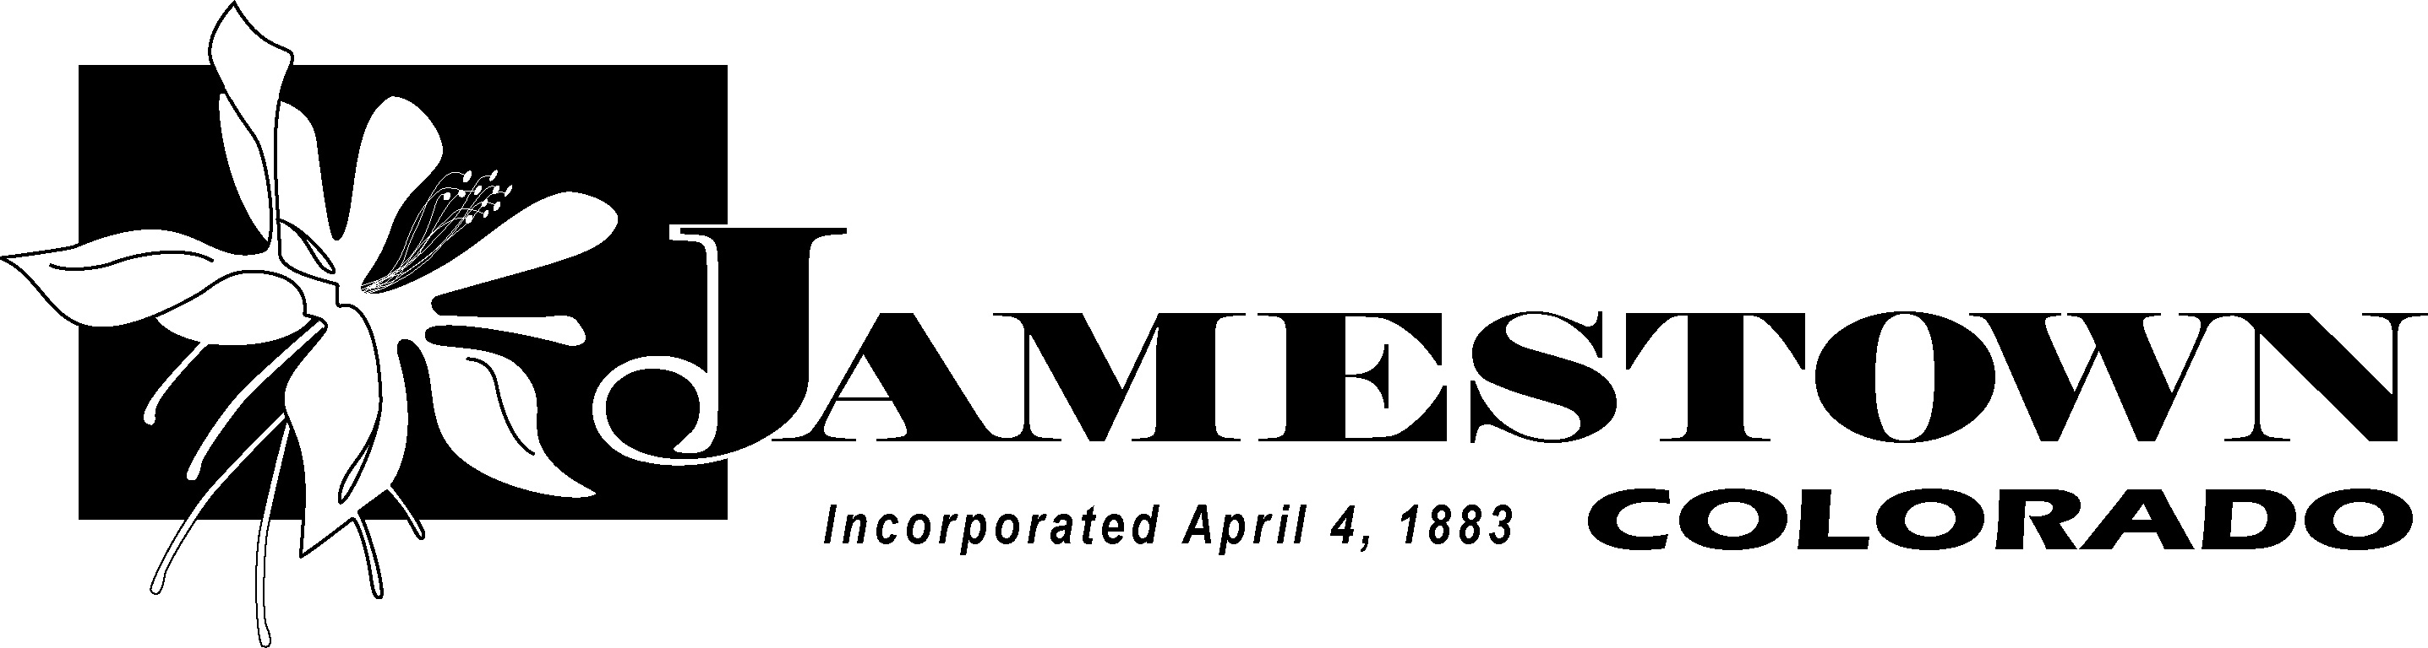
2013 Flood Fact Sheet
Updated 11/25/14
The Town of Jamestown, (located in Boulder County, Colorado, 12 miles northwest of the City of Boulder), was incorporated in 1883 after gold was discovered near Jim Creek in the 1870s. Pre-flood, our town had a population of approximately 300 people. Within our town is Jamestown Elementary School, one of the few remaining “one-room” schools in the country; the Jamestown Mercantile, which dates back to the early 1900s (presenting live music every Friday and Saturday night); a US Post Office and the Jamestown Community Church.
Our town experienced a traumatic flood event beginning on September 11, 2013 and lasting for three days. During this event we not only lost 20% of the homes in town, 50% of the roads (5,030 feet), both bridges, our water plant, but we also lost the patriarch of our community, Joe Howlett.
As a result of the physical damages sustained, 90% of our community was forced to temporarily relocate. Although this traumatic event has dramatically changed our landscape, our Community remains strong. The following depicts the challenges we face along with the milestones we have already achieved:
Challenges:
- Forty-five homes were damaged and remain in disrepair.
- Seventeen homes were completely destroyed.
- The Jamestown Fire Hall was completely destroyed.
- The Jamestown Post Office was severely damaged.
- Public infrastructure loss estimated at close to $4.5 million in damages.
- Twenty-four acres of the James Creek Stream Corridor were severely impacted.
- The Jamestown Town Square Park was completely destroyed.
- Elysian Park suffered significant damage with portions that were not accessible for 6 weeks.
- Jamestown Elementary was not severely damaged; however the school building was closed for the remainder of the 2013/2014 school year due to lack of access to emergency services and drinking water. The school met off-site at two different locations.
- The Water Treatment Plant was severely damaged; 50% of the distribution lines were destroyed.
- Andersen Hill Bridge was completely destroyed.
Milestones:
- 90% of households are currently occupied.
- The Town of Jamestown worked with AMEC, a national engineering firm, to create a Stream Corridor Master Plan to identify the new floodplain. As a result, the Town was able to lift its building permit moratorium on January 21, 2014.
- Colt & Steel completed its project to realign and armor the stream corridor in June 2014.
- Water lines were reestablished in the upper parts of town in July, and continued to the lower parts throughout August. 94.8% of functional households are currently connected to town water.
- Water main replacement was 100% complete as of October 2014.
- Potable water was reestablished on November 1, 2014.
- Before potable water was reestablished, some households installed small above-ground cisterns so they were able to live in their homes. With grants through the Red Cross, the Salvation Army, and the Flatirons Rotary Club we were able to provide 40 cisterns to bring home 98 residents.
- As of September 2014, the American Red Cross had donated 24,480 bottles and 7,360 gallons of water, and continued to donate for two months after that.
- The EPA repaired damage to the stream corridor alongside Elysian Park.
- The Jamestown Post Office reopened on February 8, 2014, 140 days after the flood.
- Volunteer stats to date: Total Volunteer Hours: 32,500 / Over 2,000 Volunteers
- Mennonite Disaster Services is working to rebuild 6 houses with voluntary labor.

